1. We have two services product and coupon. Product calls coupon service to get coupon to apply discount.

So, product service will become a **RESTful Client** for the coupon service.

1. **RestTemplate**:
   1. Spring MVC offers RestTemplate using which we can make RESTful calls.
   2. But we have to write a lot of coding.
2. **FeignClient**:
   1. Spring Boot provides FeignClient.
   2. Using FeignClient, we can create RESTful Client declaratively.
   3. It integrates better with Eureka and other Spring Cloud Projects too.
3. **Adding Dependency**:  
   
4. @EnableFeignClient  
   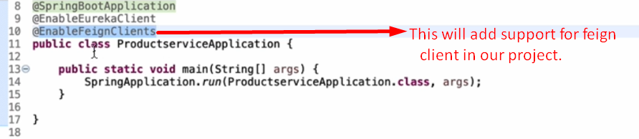
5. @**FeignClient**:
   1. 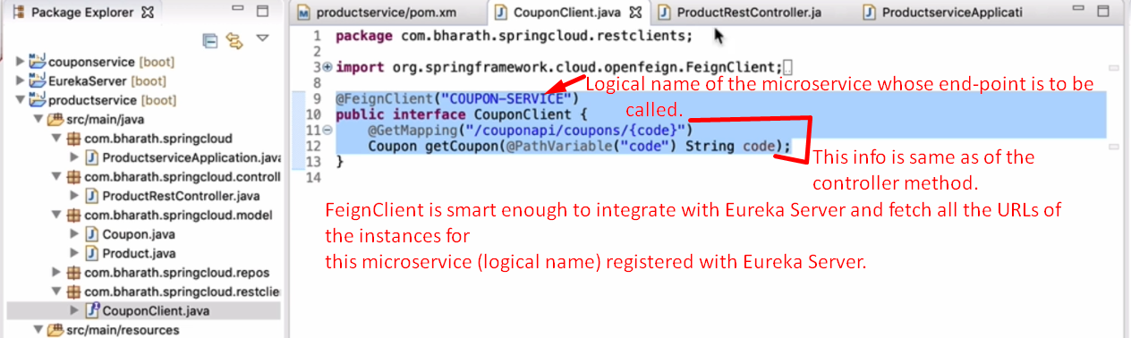
   2. 